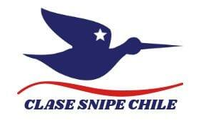

Western Hemisphere and Asia Championship Hayward Western Hemisphere Trophy
March 13 -18, 2023
Organizing Authority: Cofradia Nautica del Pacifico, (CNP) in cooperation with the Snipe Class International Racing Association and Chile Fleet #451

SAILING INSTRUCTIONS (SI)

The notation [NP] in a rule in the SI means that a breach of this rule shall not be grounds for a protest by a boat. This changes RRS 60.1(a) and 63.1

The notation [SP] in a rule in the SI means that for a breach of this rule a standard penalty will be applied without a hearing. This changes RRS A5.

The notation [DP] in a rule in the SI means that for a breach of this rule a discretional penalty will be applied by the Protest Committee.

- RULES
  - The rules as defined in the Racing Rules of Sailing (RRS).
  - The SCIRA Rules of Conduct for Conducting National and International Championship Regattas (RoC)
  - The Deed of Gift.
  - The realization and development of the event is subject to approval by the corresponding health authorities
  - [NP][DP] The current COVID- 19 protocols of the Health Authority if apply
  - If there is a conflict between languages the English text will take precedence.
  - No National prescription will apply.
  - The Rules of Conduct for Conducting National and International Championship Regattas will apply. Any conflict arising between the Deed of Gift and the SCIRA Rules of Conduct shall be solved by the application of the Rules of Conduct.
  - In case of conflict between the Notice of Race and the Sailing Instructions the Sailing Instructions shall prevail. This changes RRS 63.7
  - [NP][DP] Bow numbers are assigned at registration and it shall be each competitor’s sole responsibility to properly affix them in conformance with the instructions and to properly maintain them.

- NOTICES TO COMPETITORS
  - Notices to competitors will be posted on the official notice board(s) located nearby the Championship Office.

- CHANGES TO SAILING INSTRUCTIONS
  - Any change to the sailing instructions will be posted before 11:00 am on the day it will take effect, except that any change to the schedule of races will be posted by 08:00 pm on the day before it will take effect.
  - Any change or amendment to the Sailing Instructions shall be approved by the SCIRA Representative.

- SIGNALS MADE ASHORE
  - Signals made ashore will be displayed at the Club mast
  - When the “AP” race signal is displayed ashore, ‘1 minute’ is replaced with ‘not less than 60 minutes’ in the race signal “AP”. This changes Race Signals
  - [NP] [DP]. When the “AP over H” race signal is displayed ashore, the boats shall not leave the harbor. The warning signal will be made in no less than 60 minutes after the signal is lowered with one sound. This changes Race Signals

- SCHEDULE
  - Dates of racing:

Date | Activity
Mar, 13th | 10:45 Competitors Meeting  13:00 Practice Race  18:00 Opening Ceremony and Dinner
Mar, 14th | 12:00 Warning Signal Race  Aprox. 18:00 After Race
Mar, 15th | 12:00 Warning Signal Race  Aprox. 18:00 After Race
Mar, 16th | 12:00 Warning Signal Race  Aprox. 18:00 After Race
Mar, 17th | 12:00 Warning Signal Race  Aprox. 18:00 After Race
Mar, 18th | 12:00 Warning Signal Race  Aprox. 18:00 Closing Ceremony and Prize giving, plus Cocktail

  - The regatta shall consist of nine (9) races.
  - No more than two (2) races shall be sailed per day; three (3) races can be sailed only if behind schedule.
  - In case of a prolonged postponement, to alert boats that a race or sequence of races will begin soon, an orange flag will be displayed with one sound for at least four minutes before a warning signal is made.
  - On the last day of racing no warning signal will be made after 04:30 pm.
  - There will be competitors meeting on Monday 13th, at 10:45 am at Rincon del Navegante and announced by two sound signals.

- CLASS FLAGS
  - The official Class Flag shall be the Snipe Class flag, a red Snipe on a white background.

- RACING AREAS
  - Attachment A shows the location of the racing areas.

- WEATHER LIMITATION (Course and Starting)
  - The wind speed ranges shall be no less than 5 knots and not exceed 23 knots or in accordance with the Rules of Conduct for Conducting National and International Championships and the applicable Deed of Gift.

- THE COURSES
  - The diagrams below show the courses, including the approximate angles between legs and the order in which marks are to be passed. All course marks (except gates) shall be left to port.
  - The course signal (code flag “W”, “T”, “O”, “W2”, “T2” or “O2”) shall be hoisted with one sound at least one minute before the warning signal. It will remain displayed for no less than five minutes after the start.
  - No later than the warning signal, the Race Committee signal boat will display the approximate compass bearing of the first leg.
  - If during a race the wind and/or wave action changes to the point where the selected course would be inadvisable (See Course Selection Diagram), the Race Committee shall change the course at any mark. A change of the type of course during the race shall be signaled by displaying the new appropriate flag and accompanied by repetitive sounds before the leading boat has passed or rounded the mark.
  - A sustained wind variation of 20 degrees or more from the posted bearing during the first leg of a race shall result in the race being abandoned and resailed, or abandoned. This changes RRS 32.1.
  - A sustained wind variation of 40 degrees or more from the posted bearing during the first lap shall result in the race being abandoned and resailed, or abandoned. For the purpose of this rule, a lap means the rounding of mark 3 (or passing the gate 3s-3p) for the first time. This changes RRS 32.1.
  - The number of legs in a race may be reduced (RRS code flag S) but at least 2 (two) windward legs of the race shall be completed. This changes RRS 32.2.

- MARKS
  - Marks 1, 1bis, 2, 3, 3s and 3p will be Orange inflatable buoys.
  - New mark will be a Yellow inflatable buoy.
  - The port-end starting mark will be: An inflatable Yellow buoy.
  - The finishing mark will be:
    - Mark 1 for “W”, “O”, and “T” courses, or
    - a orange buoy for “W2”, “O2”, and “T2” courses
  - A Race Committee vessel signaling a change of a leg of the course is a mark as provided in SI 12.2.
  - If one of the marks "gate 3s-3p" is not placed, or is not replaced as per RRS 34, the remaining mark shall be left to port. This changes RRS 34.

- THE START
  - The starting line will be between a staff displaying an orange flag on the Race Committee vessel at the starboard end and the course side of the starting mark or a staff displaying an orange flag on another boat.
  - A boat starting later than 5 minutes after her starting signal will be scored Did Not Start without a hearing. This changes RRS A4 and A5.
  - The Race Committee, after the finish of a race and before the warning signal of a subsequent one, will do its best to post on the Race Committee vessel a list of OCS, ZPF, or UFD boats. The failure of posting an incomplete or wrong list will not be grounds for redress. This changes RRS 62.1(a).
  - A list of boats that have been scored OCS, ZPF, and UFD will be posted on the Official Notice Board.

- CHANGE OF THE NEXT LEG OF THE COURSE
  - To change the next leg of the course, the Race Committee will lay a new mark (or move the finishing line) and remove the original mark as soon as practicable. When in a subsequent change a new mark is replaced, it will be replaced by an original mark.
  - Except at a gate, boats shall pass between the race committee boat signaling the change of the next leg and the nearby mark, leaving the mark to port and the Race Committee vessel to starboard. This changes RRS 28.
  - After the completion of the first windward leg of the race the remaining legs may be increased or decreased by not more than 30% of the original length. This changes RRS 33

- THE FINISH
  - The finish line will be between a staff displaying an orange flag on a Race Committee vessel and the course side of the finishing mark OR the staff displaying an orange flag on the finishing buoy as provided in 10.4.
  - The A flag on the Race Committee boat at the finish means that there will be no more races for the day.

- PENALTY SYSTEM
  - Appendix P will apply with the following changes:
    - P2.3 is deleted
    - P2.2 will apply to subsequent penalties

- TIME LIMITS AND TARGET TIMES
  - The races will be managed to last 60-75 minutes for the first boat to finish. A different time (shorter or longer) used to complete the race will not be ground for requesting redress.
  - The time limit for the first boat to complete the first lap is 40 minutes from the start. If the first boat fails to complete the first lap within 40 minutes the Race Committee shall abandon the race. For the purpose of this rule a lap means the rounding of Mark 3 (or passing the Gate 3s/3p) for the first time.
  - The time limit for the first boat to finish the race shall be 1 hour, 30 minutes. Any boat finishing more than 30 minutes after the first boat finishes or failing to finish within 2 hours from the start, whichever is shorter shall be scored Did Not Finish (DNF). This changes RRS 35, A4 and A5.

- PROTESTS AND REQUESTS FOR REDRESS
  - Protest forms are available at the race office, located at the CNP principal building. Protests and requests for redress or reopening shall be delivered there within the appropriate time limit.
  - The protest time limit is 90 minutes after the last boat has finished the last race of the day or the Race Committee signals no more racing today, whichever is later.
  - Notices will be posted no later than 30 minutes after the protest time limit to inform competitors of hearings in which they are parties or named as witnesses.
  - Hearings will be held in the protest room, located at CNP Principal Building, beginning
at the time posted.
  - A list of boats that have been penalized for breaking RRS 42 will be posted on the Official Notice Board.
  - The penalty for breaking rules in the SI marked with [SP] may be applied at the discretion of the Race Committee, and shall be the 5% scoring penalty for nearest race completed by the infringing boat but not worse than the number of points corresponding to DSQ. This changes RRS 63.1 and A5.
  - Penalties for breaking Class Rules may be less than disqualification.
  - A list of boats that have been penalized as per SI 17.5 and 18.2 will be posted on the Official Notice Board.
  - On the last scheduled day of racing a request for redress based on a protest committee decision shall be delivered no later than 30 minutes after the decision was posted. This changes RRS 62.2.
  - An International Jury is constituted and shall have authority per RRS Appendix N. Their decision shall be final as provided in RRS 70.5.
  - Per Appendix N2.2, SCIRA reserves for itself the right and responsibility to decide issues of eligibility, measurement and equipment. SCIRA may refer any issue to the International Jury for advice.
  - The use of team racing tactics shall not be tolerated.
  - For the purpose of RRS 64.4(b) the “authority responsible” is the Measure of the event.
  - The Jury will abandon the race if, during a redress hearing, they conclude that the Race Committee did not follow Sailing Instructions 8, 9.5, 9.6, 9.7, and 12.3. This changes RRS 64.3.

- SCORING
  - Five (5) races are required to be completed to constitute a series.
  - When fewer than six (6) races have been completed, a boat’s series score will be the total of her race scores.
  - When 6 to 9 races have been completed, a boat’s series score will be the total of her race scores excluding her worst score.
  - [NP][DP] A boat intending to retire and be scored RET shall report its intent in writing to the Race Committee or the Jury within the protest time limit.

- [NP][DP] SAFETY REGULATIONS
  - Before the warning signal of the first race of the day each boat is required to sail past the stern of the Race Committee boat on starboard tack and verbally check in. The check- in boat will display a “L” Flag while on station prior to the first warning signal. When the Race Committee verbally acknowledges a boat’s bow number, the check-in has been officially noted.
  - A boat that retires from a race shall notify the Race Committee as soon as possible.

- REPLACEMENT OF CREW OR EQUIPMENT
  - The same crew shall race in all races, except for reasons satisfactory to the Race Committee. Requests for a change of crew shall be submitted in writing to the Chairman. Once a crew has been excused, he/she may not return for the balance of the series.
  - The same skipper shall sail all races and can be replaced after the first race only, and then only if he/she is obviously incapacitated. If a skipper is replaced the first race shall be the race dropped, or scored DNC.
  - [DP] Substitution of damaged or lost equipment will not be allowed unless authorized by the Technical Committee. Requests for substitution shall be made to the Technical Committee at the first reasonable opportunity.

- [NP] EQUIPMENT AND MEASUREMENT CHECKS
  - A boat or equipment may be inspected at any time for compliance with the Class Rules and Sailing Instructions. On the water, a boat can be instructed by the Technical Committee, or the equipment inspector or measurer, to proceed immediately to a designated area for inspection.

- [NP][SP] EVENT ADVERTISING
  - Boats shall display event advertising supplied by the organizing authority as follows: Bow number Sticker, 5 cm from the deck and 25 cm from the top of the stem. See Attachment B.

- RIGHTS TO USE NAME AND LIKENESS
  - By participating in this event, competitors automatically grant to the SCIRA, organizing authority and the event sponsors the right, in perpetuity, to make, use, and show, at their discretion, any photography, audio and video recording, and other reproductions of them made at the venue or on the water from the time of their arrival at the venue, until their final departure, without compensation.

- [NP] [DP] SUPPORT BOATS
  - At the preparatory signal, coaches must be positioned at least 50 meters below the starting line and its extensions. After the starting signal coaches may follow the fleet, but only on the port side of the course and must stay at least 50 meters from any mark.
  - Coaches shall not communicate with competitors after the warning signal for any race until after the competitors have finished the race.
  - Coaches shall register at the Regatta Office and all support boats shall be identified with the sticker number provided by the Organizing Authority.

- [DP] RADIO COMMUNICATIONS
  - A boat that is racing shall not make voice or data transmissions and shall not receive voice or data communication that is not available to all boats, except in an emergency or when using equipment provided by the race committee. This restriction also applies to mobile telephones.

- [DP] DRONES
  - No drones are allowed closer than 500 m from racing areas from the Warning Signal for a race and after the last boat has finished the race. As a penalty for breaching this rule the protest committee may impose a discretionary penalty (DP) to all boats associated with the owner / operator of the drone. This does not apply to OA drones.

- [NP] [DP] TRASH DISPOSAL
  - Trash may be placed aboard support and Committee Vessels.

- PRIZES
  - Prizes shall be awarded as provided by NoR.

Signatures
Race Committee Chairman: Alberto Prieto
Regatta Officer: Cristián González
Jury Chairman: Juan Andrés Mac Call
Jurires:
Andres Anca (ARG)
Nelson Ilha (BRA)
Jose Paulo Fuentes (CHI)
Kattalina Muriche (PE)
SCIRA Representante:Jerelyn Biehl (USA)
Paola Prada (BRA)

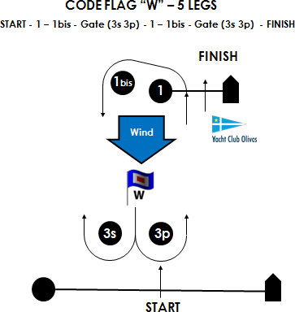
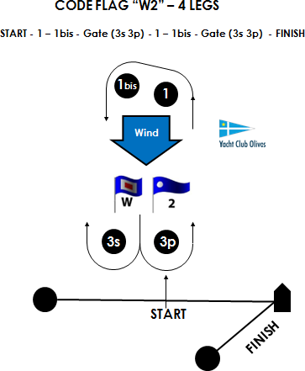

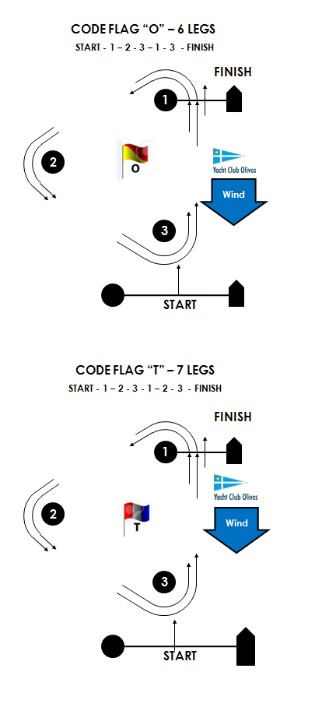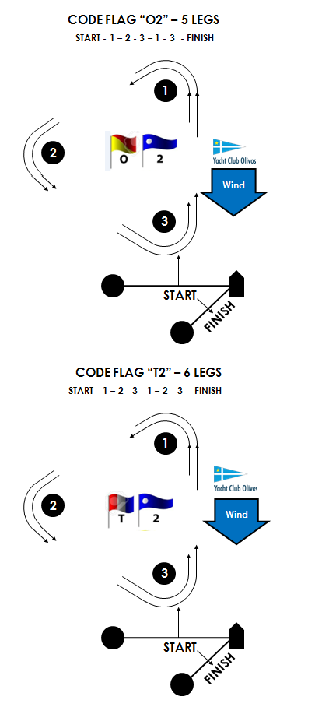

ATTACHMENT B / ANEXO B
How to paste the bow numbers: number to / Cómo pegar el número de Proa Number to Stem. / Numero hacia la Roda

